# A….-ASIA-Indus-Zebu male bull figurine-Terracotta-3000 BCE

Case no.: 3.

Accession Number: A….

Formal Label: Indus-Zebu male bull figurine-Terracotta-3000 BCE

**Display Description:**

This Indus Zebu bull suggests an importance to the community through his eyes. This male bull is characterized by stylized facial features especially is smiling mouth, wide open circular eyes and large pupils. The short tapered legs end with little feet.

**LC Classification:** PK119

Date or Time Horizon: 3000 BCE

Geographical Area: Indus Valley

INCLUDEPICTURE "https://upload.wikimedia.org/wikipedia/commons/5/50/Carte_Indus.jpg" \* MERGEFORMATINET 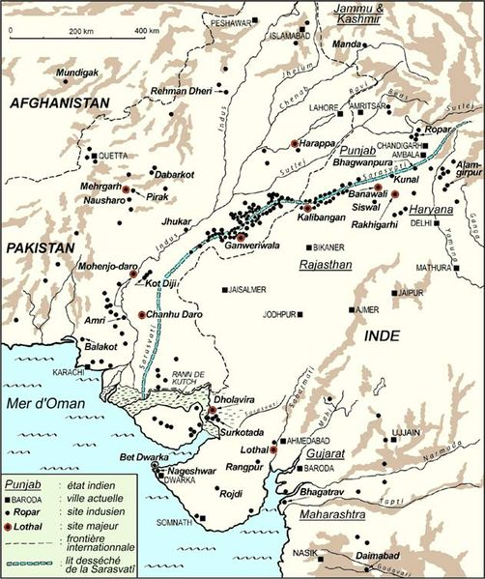

Cultural Affiliation: Indus

Media: terracotta, black pigment

Dimensions: - L 10.2 cm; 4 in.

Weight:

Condition: original

Provenance: Ex: American private collection 1970s. **Discussion:**

**References:**